DLD lab report 2
student number: 16329561

We needed to implement a product-of-sum function F(X,Y,Z) = (X+Z).(Y’+Z).(X’+Y+Z) using only NOR gates and inverters.

The circuit is as following:

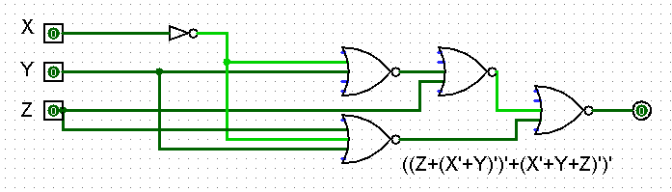
It uses one inverter, 3 2-inputs NOR gates and one 3-inputs NOR gate. The truth table is as following:

X | Y | Z | F(X,Y,Z)
0 | 0 | 0 | 0
0 | 0 | 1 | 1
0 | 1 | 0 | 0
0 | 1 | 1 | 1
1 | 0 | 0 | 0
1 | 0 | 1 | 1
1 | 1 | 0 | 0
1 | 1 | 1 | 1

Boolean algebra:

Starting from the POS function we get: F(X,Y,Z) = (X+Z).(Y’+Z).(X’+Y+Z)
= (Z+XY’).(X’+Y+Z)
= (Z+(X’+Y)’).(X’+Y+Z)
= ((Z+(X’+Y)’)’+(X’+Y+Z)’)’

We can show with boolean algebra that the function can be reduced to just Z state.

F(X,Y,Z) = (X+Z).(Y’+Z).(X’+Y+Z)
= (Z+XY’).(X’+Y+Z)
= (Z +(XX’Y+XYY’)
= (Z+(0+0))
= Z+0
= Z

